LICENTA

Enhancing Our Lives Through Music:

Genre Classification and Generation

Abstract:

In this paper, I investigate a comprehensive approach to music genre classification and generation, utilizing a combination of deep neural networks, machine learning algorithms, variational autoencoders (VAEs), long short-term memory (LSTM) networks, and Transformers. My research aims to advance the understanding of music's impact on our lives and develop methodologies to create diverse and engaging musical experiences tailored to individual preferences.

I begin by extracting relevant features from a large and diverse collection of music samples from different genres. These features, encompassing spectral properties, rhythmic patterns, and tonal characteristics, serve as the foundation for my genre classification and generation models. I employ deep neural networks and machine learning algorithms to effectively classify music genres by capturing the distinct characteristics of each genre.

In order to generate music, I explore the potential of VAEs, LSTMs, and Transformers, each offering unique capabilities for handling different aspects of the task. VAEs are employed to learn a continuous latent space representation of the music samples, enabling the generation of novel compositions within a specified genre. LSTMs and Transformers, on the other hand, are used to model the temporal dependencies and intricate patterns inherent in music.

My methodology is evaluated through a series of experiments, with the results compared against conventional machine learning algorithms and other deep learning architectures. While not claiming state-of-the-art performance, my approach demonstrates promising outcomes in both classification and generation tasks, showcasing its potential to enhance music-related applications such as recommendation systems and creative tools for composers.

In conclusion, the suggested framework provides a flexible and thorough answer, opening the door for more research and advancement in music technology.

Contents

1. Introduction 4

1.1. Motivation 4

1.2. Outline of the thesis 5

1.3. Application fields 5

2. Related work 6

2.1. Similar research 7

2.1.1. Music Genre Classification 7

2.1.2. JukeBox 7

2.1.3. Groove2Groove 7

2.2. Applications in the field 7

2.2.1. Spotify 7

2.2.2. SoundHound 8

2.2.3. Soundraw 9

3. Technical background 10

3.1. EDA 11

3.1.1. Correlation Heatmap 12

3.1.2. Principal Component Analysis 13

3.1.3. Feature Engineering 15

3.1.4. Feature selection 16

3.2. Music Genre Recognition 16

3.2.1. Audio signals 18

3.2.1.1. Chroma STFT 20

3.2.1.2. RMS 21

3.2.1.3. Spectral centroid 21

3.2.1.4. Spectral bandwidth 22

3.2.1.5. Rolloff 23

3.2.1.6. Flatness 23

3.2.1.7. Contrast 23

3.2.1.8. Flux 24

3.2.1.9. Zero crossing rate (ZCR) 24

3.2.1.10. Harmonics 24

3.2.1.11. Percussive 24

3.2.1.12. Tempo 25

3.2.1.13. MFCC 25

3.3. Music Generation 25

4. Proposed framework 26

4.1. Music Genre Recognition 26

4.2. Music Generation 26

5. Evaluation 26

5.1. Music Genre Recognition 26

5.2. Music Generation 26

6. Conclusion and future work 26

7. Bibliography 26

# 1. Introduction

## 1.1. Motivation

The transformative power of music has been a cornerstone of human culture and expression throughout history. As diverse as our societies, the vast array of music genres reflects our rich cultural heritage and individual creativity. With the rapid advancements in technology, new paradigms in music analysis and synthesis are emerging, further enhancing our understanding of this universal language.

The motivation for this research paper stems from a desire to harness the potential of cutting-edge learning techniques, such as Machine Learning, Deep Neural Networks (DNNs), Long Short-Term Memory (LSTM) networks, Variational Autoencoders (VAEs), and Transformers, to address two primary challenges in the field of music informatics: genre classification and music generation.

The accurate classification of music genres is a crucial task that aids in music discovery, recommendation, and tagging. However, the subjective nature of genre definitions and the complexity of musical elements make this a challenging problem. By employing deep neural networks and machine learning techniques, this research aims to develop robust and sophisticated models that can effectively capture the intricate patterns and features of various music genres, leading to improved classification performance.

The creative process of composing music has long been considered the exclusive domain of human intellect. However, recent advancements in artificial intelligence and machine learning have demonstrated the potential for machines to generate music with remarkable coherence and originality. This research explores the application of LSTM, VAE, and Transformer models to the task of music generation, with the goal of developing systems capable of producing high-quality compositions across different genres, while respecting the unique characteristics and structures inherent to each.

By combining expertise in music theory, machine learning and artificial intelligence, this research paper aims to contribute to the ongoing efforts to revolutionize the field of music informatics. It is hoped that the findings will not only serve as a foundation for future research endeavors but also pave the way for innovative applications that enrich our understanding and appreciation of the world of music.

“Music gives a soul to the universe, wings to the mind, flight to the imagination, and life to everything.” – Plato

## 1.2. Outline of the thesis

This thesis is organized as follows:

After providing a brief introduction to the goals and motivation of this research paper, Chapter 2 will present various related experiments that demonstrate diverse approaches to music classification and generation. These studies include unique datasets, models, metrics, and results, giving a well-rounded view of the different methods used in this field.

Moving forward, Chapter 3 offers a comprehensive exploration of music theory, delving into the various theoretical elements, structures and algorithms employed throughout this study. Chapter 4 thoroughly outlines the data preparation process for information extraction, the selected models, and the overall framework. Chapter 5 then explores the interpretation of outcomes and showcases a selection of pertinent metrics that effectively represent the issues under discussion.

Music tagging, like identifying genres or emotions, is a common practice in the music industry. However, there hasn't been a ton of work done in generating music in a specific style. Despite this, the work that has been done is pretty varied, because it can involve different ways of representing music and address different concepts. Pursuing the directions offered in this study, numerous intriguing concepts merit further exploration, including transferring styles between songs while preserving the original content or making remixes of melodies while controlling specific attributes like chromaticism, groove, or instrumentation, aspects discussed in Chapter 6.

## 1.3. Application fields

The swift advancement of machine learning and artificial intelligence methodologies has accelerated the growth of music information retrieval and music creation. These technologies offer numerous applications, which possess the potential to radically transform our interaction, consumption and production of music.

Content-based music retrieval and recommendation systems constitute a principal application domain of music genre identification. By classifying music tracks into well-defined genres, these systems can deliver customized music suggestions based on users' predilections and listening behavior. Additionally, refined genre identification can aid in enhancing playlist creation, empowering users to uncover new music within their favored genres or based on their listening mood.

Music genre identification is integral to Music Information Retrieval (MIR), an interdisciplinary area concerned with extracting and organizing information from music. Advanced genre identification methods streamline the examination and cataloging of extensive music databases, facilitating the detection of patterns, trends, and connections between various musical pieces and enriching our comprehension of music as a cultural phenomenon.

On the other hand, music creation techniques have given rise to interactive music composition tools, allowing users to produce original music with minimal expertise. Employing AI-generated music, these tools can support users in composing melodies, harmonies, and rhythms, enabling them to concentrate on their artistic vision. Furthermore, such tools can serve educational purposes, assisting budding musicians in honing their skills and grasping music theory.

Automatic music transcription systems can leverage improvements in music genre identification and music creation. By incorporating genre-specific knowledge, these systems can enhance their precision in transposing audio recordings into symbolic notation, enabling musicians to analyze, modify, and perform the transcribed music more effectively.

Music creation techniques have been applied to video game and film scoring. AI-generated music can adapt to the dynamic nature of video games, offering immersive and responsive auditory experiences for players. Similarly, in the film industry, AI-generated music can function as an economical alternative to conventional scoring methods, addressing the unique demands of individual scenes and narratives.

Music therapy has long been acknowledged for its potential advantages in fostering mental and emotional well-being. AI-generated music can be customized to address the specific requirements of individuals, delivering personalized therapeutic experiences. Additionally, music creation techniques can be employed in the development of assistive technologies for people with disabilities, enabling them to interact with music in innovative and accessible ways.

# 2. Related work

## 2.1. Similar research

### 2.1.1. Music Genre Classification

The paper at [[derekahuang/Music-Classification (github.com)](https://github.com/derekahuang/Music-Classification)]

### 2.1.2. JukeBox

The paper at [[Jukebox: A Generative Model for Music (arxiv.org)](https://arxiv.org/pdf/2005.00341.pdf)]

### 2.1.3. Groove2Groove

The paper at [[taslp-3019642-pp.pdf (hal.science)](https://hal.science/hal-02923548v2/document)]

## 2.2. Applications in the field

### 2.2.1. Spotify

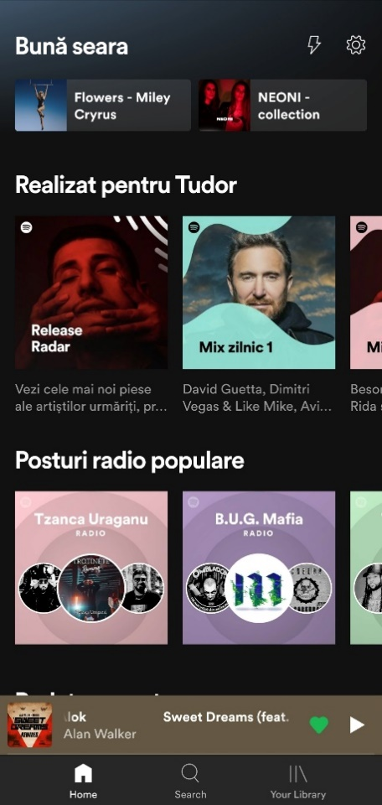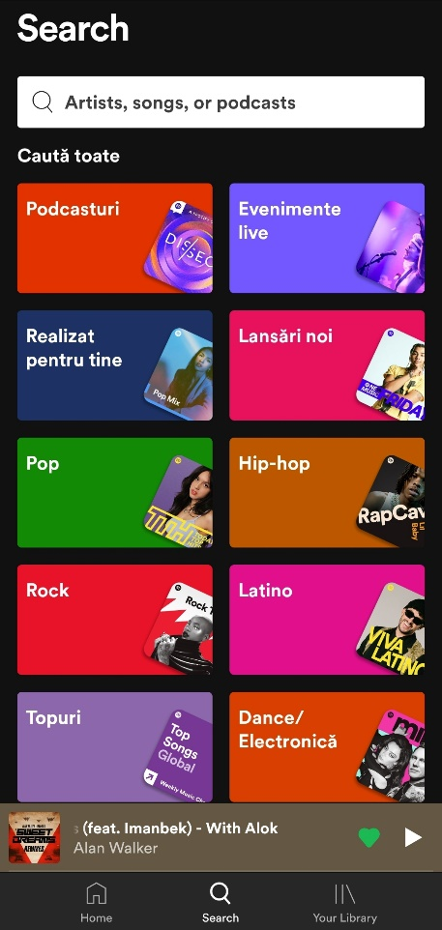

### 2.2.2. SoundHound



### 2.2.3. Soundraw

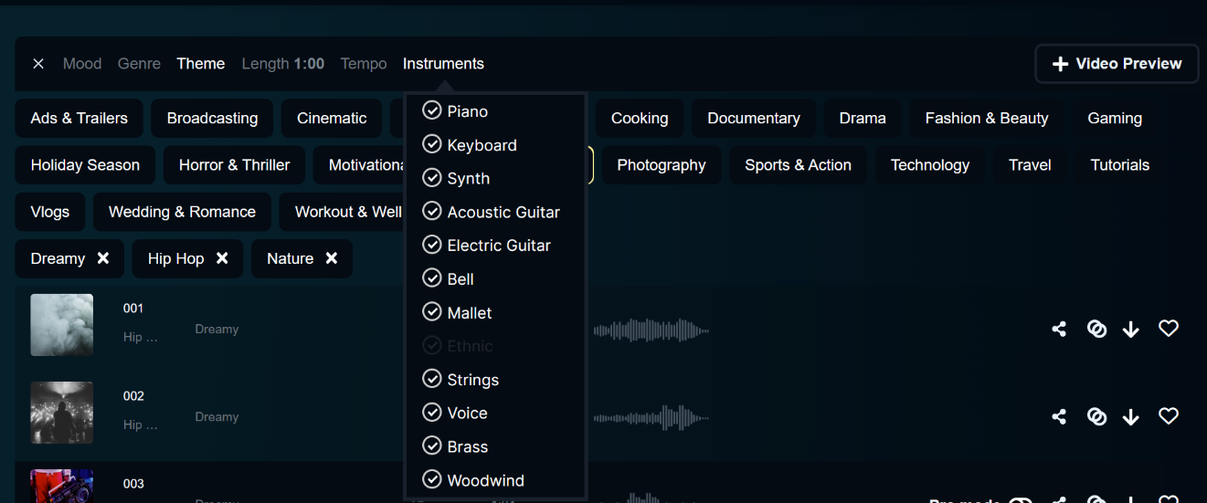

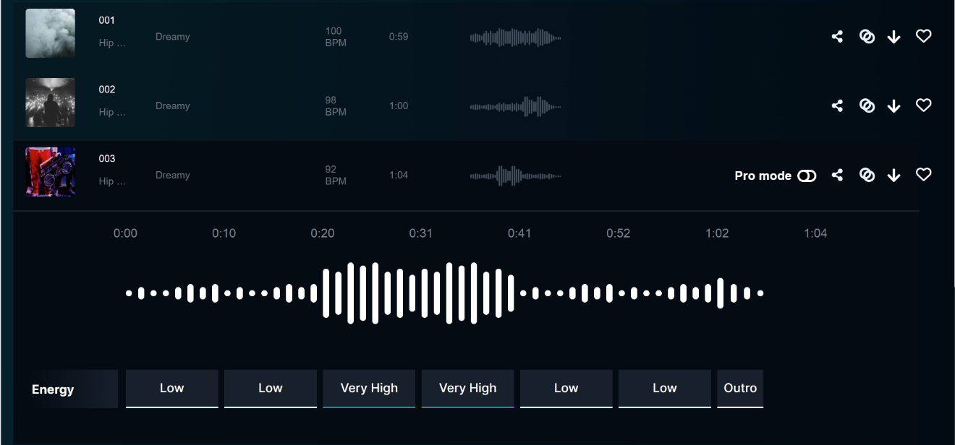

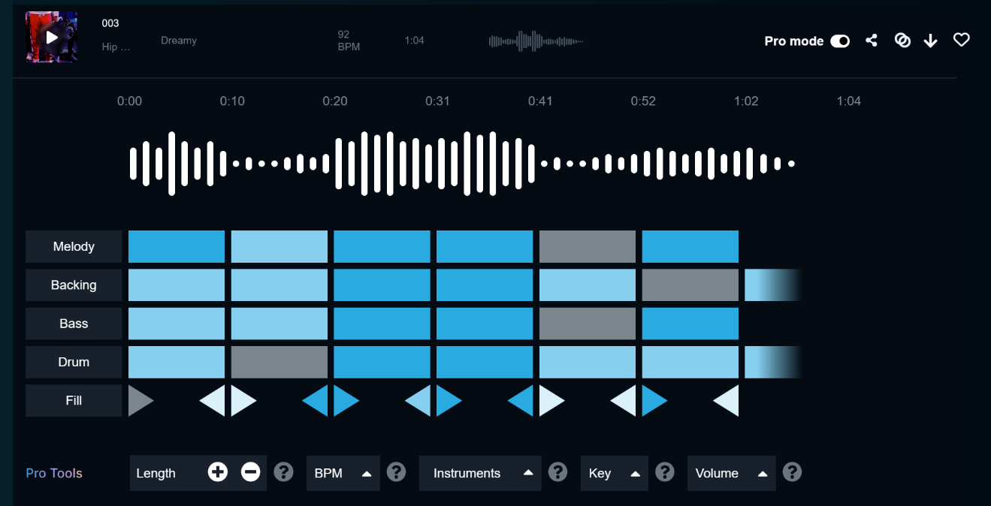

# 3. Technical background

Music Information Retrieval (MIR) is a field that involves the study of processing audio signals in order to access relevant information from music. It combines elements of music theory, physics, psychology, signal processing, linguistics, mathematics and computer science. A few applications to this field include:

1. Understanding Music Data: Music can be represented in various formats, such as audio signals, symbolic notations, or lyrics. MIR aims to extract meaningful information from these different data representations.

2. Feature Extraction: This process involves identifying key aspects of music data, such as pitch, tempo, rhythm, melody, harmony, and timbre. These features can help in the analysis and categorization of music.

3. Music Analysis: MIR can be used to analyze music on various levels. This includes low-level analysis (determining the beat or pitch), mid-level analysis (identifying beat tracking or chord recognition) and high-level analysis (classifying the genre or mood of a piece).

4. Search and Recommendation: techniques in the field are often used in music recommendation systems, such as those found in Spotify or Pandora. These systems analyze the features of music to provide personalized recommendations to users.

5. Music Transcription: it also encompasses automatic music transcription, which is the process of converting a music audio signal into a symbolic representation such as sheet music or MIDI.

6. Music Classification and Clustering: these techniques can also be used to classify music into different genres, moods, or even identifying similar songs which is extremely useful in music libraries and streaming platforms to organize music and create playlists.

7. Music Generation: MIR is also used in music generation, where algorithms learn the patterns in music data to create new compositions.

Research in Music Information Retrieval can lead to advancements in various applications such as music search engines, digital libraries, music composition software, interactive music systems, and even music education and therapy. However, it also poses great challenges due to the complexity and subjectivity of music perception.

## 3.1. EDA

[[What is Exploratory Data Analysis? | IBM](https://www.ibm.com/topics/exploratory-data-analysis)]

Exploratory Data Analysis (EDA) is a strategic approach employed by data scientists to analyze and investigate datasets, thereby summarizing their predominant characteristics, frequently via visualization techniques. It helps in identifying the most efficient way to manipulate data sources to derive the required information, discovery of patterns, detection of anomalies, hypothesis testing and verification of assumptions.

Primarily, EDA is utilized to glean insights that data can offer beyond the conventional modeling or hypothesis testing activities. It bestows a more profound understanding of the dataset's variables and their interrelationships. Moreover, it can assist in verifying whether the statistical techniques considered for data analysis are appropriate.

The core objective is to enable an in-depth examination of data prior to making any assumptions. It facilitates the identification of apparent errors, deeper comprehension of data patterns, detection of outliers or anomalous occurrences and discovery of interesting relationships among variables.

In the realm of data science, exploratory analysis serves to validate the results, ensuring their applicability to the intended outcomes and objectives. It further confirms the relevance of the questions being asked. It also provides answers regarding standard deviations, categorical variables, and confidence intervals. Upon completion of EDA and drawing of insights, its attributes can be employed for more advanced data analysis or modeling, including machine learning.

Specific statistical functions and techniques that can be performed with EDA tools include:

* Clustering and dimension reduction techniques, which help create graphical displays of high-dimensional data containing many variables.
* Univariate visualization of each field in the raw dataset, with summary statistics.
* Bivariate visualizations and summary statistics that allow you to assess the relationship between each variable in the dataset and the target variable you’re looking at.
* Multivariate visualizations, for mapping and understanding interactions between different fields in the data.
* K-means Clustering is a clustering method in [unsupervised learning](https://developer.ibm.com/articles/cc-unsupervised-learning-data-classification) where data points are assigned into K groups, i.e. the number of clusters, based on the distance from each group’s centroid. The data points closest to a particular centroid will be clustered under the same category. K-means Clustering is commonly used in market segmentation, pattern recognition, and image compression.
* Predictive models, such as linear regression, use statistics and data to predict outcomes.

### 3.1.1. Correlation Heatmap

A correlation heatmap is a type of data visualization tool that represents the correlations between multiple variables in a dataset. It's a grid of cells, where each cell represents a correlation coefficient between two variables. It's especially useful for feature selection in machine learning, identifying multicollinearity in regression analysis and for exploratory data analysis.

**Correlation** is a statistical measure that describes the degree of relationship between two variables. The correlation coefficient shows the strength of the correlation and its magnitude can range from -1 to 1. A correlation of -1 indicates a perfect negative correlation (as one variable increases, the other decreases), a correlation of 1 indicates a perfect positive correlation (as one variable increases, the other increases as well) and a correlation of 0 indicates no linear relationship between the variables. However, a correlation between two variables does not imply causation, it only indicates a statistical relationship between the variables. Further investigation is needed to determine if one variable is causing the other.

A **heatmap** is a graphical representation of data where values are depicted by color. It gives a visual representation of data using colors, where higher intensity ("hotter" / brighter) colors represent higher values, and lower intensity ("cooler" / darker) colors represent lower values. Heatmaps are used when there are too many data points to plot individually. The color of the cell is indicative of the correlation coefficient: positive correlations are displayed in one color gradient (increasingly intense shades of red) and negative correlations in another color gradient (increasingly intense shades of blue).

A correlation heatmap is useful for:

- Visual representation: easier to understand and interpret the relationships between variables, especially when dealing with a large number of them.

- Identifying relationships: highlights the variables that are highly correlated with each other and those that have little or no correlation.

- Feature selection: by identifying the variables that are highly correlated with the target variable, one can choose the most important variables for the model, reducing the risk of overfitting and improving model performance.

- Data cleaning: identify and remove redundant or unnecessary variables, which can improve the accuracy of the analysis and the interpretability of the results.

- Hypothesis testing: generate hypotheses about the relationships between variables, hypotheses that can then be tested further through statistical analysis.

### 3.1.2. Principal Component Analysis

Principal Component Analysis (PCA) is a dimensionality reduction method that is often used **to reduce the dimensionality** of large data sets, by transforming a large set of variables into a smaller one that **still contains most of the information** in the large set.

Reducing the number of variables of a data set naturally comes at the expense of accuracy, but the trick in dimensionality reduction is to trade a little accuracy for simplicity. Because smaller data sets are easier to explore and visualize and make analyzing data points much easier and faster for machine learning algorithms without extraneous variables to process.

PCA can be broken down into five steps:

1. **Standardization**: The aim of this step is to standardize the range of the continuous initial variables so that each one of them contributes equally to the analysis. It is critical to perform standardization prior to PCA, because the latter is quite sensitive regarding the variances of the initial variables. That is, if there are large differences between the ranges of initial variables, those variables with larger ranges will dominate over those with small ranges, which will lead to biased results. Mathematically, for each value of each variable:
2. **Covariance Matrix Computation**: Sometimes variables are highly correlated in such a way that they contain redundant information. It is the sign of the covariance that really matters: when positive, the two variables increase/decrease together (correlated); when negative, as one increases, the other decreases (inversely correlated).
3. **Eigenvectors and eigenvalues**: Principal components are new variables that are constructed as linear combinations or mixtures of the initial variables. These combinations are done in such a way that the new variables (principal components) are uncorrelated and most of the information within the initial variables is squeezed or compressed into the first components. Geometrically speaking, principal components represent the directions of the data that explain a maximal amount of variance, that is to say, the lines that capture most information of the data. The relationship between variance and information is that the larger the variance carried by a line, the larger the dispersion of the data points along it, and the larger the dispersion along a line, the more information it has. To put all this simply, just think of principal components as new axes that provide the best angle to see and evaluate the data, so that the differences between the observations are better visible. Without further ado, it is eigenvectors and eigenvalues who are behind the PCA, because the eigenvectors of the Covariance matrix are actually the directions of the axes where there is the most variance (most information) and that we call Principal Components. And eigenvalues are simply the coefficients attached to eigenvectors, which give the amount of variance carried in each Principal Component. By ranking the eigenvectors in order of their eigenvalues, highest to lowest, it results the principal components in order of significance.
4. **Feature vector**: The feature vector is simply a matrix that has as columns the eigenvectors of the components that we decide to keep. This makes it the first step towards dimensionality reduction, because if we choose to keep only p eigenvectors (components) out of n, the final data set will have only p dimensions.
5. **Recast data along PCA axes**: Until the current step, the input data set remains the same in terms of the original axes (in terms of the initial variables). In this last step, the aim is to use the feature vector formed using the eigenvectors of the covariance matrix, to reorient the data from the original axes to the ones represented by the principal components. This can be done by multiplying the transpose of the original data set by the transpose of the feature vector.

PCA is useful for:

- Dimensionality reduction: reduce the dimensionality of a data set, which can be especially useful when dealing with high-dimensional data. This can improve the performance of machine learning models, increase the interpretability of the results, and reduce the risk of overfitting.

- Data visualization: visualize complex data sets by projecting the data onto the principal components. This can help to identify patterns and relationships in the data that may not have been apparent in the original variables.

- Data compression: compress the data by retaining only the most important components and discarding the others. This can reduce the storage and computation requirements for large data sets.

- Noise reduction: remove noise from the data by retaining only the components that explain the most variance. This can improve the accuracy and stability of the results.

- Feature extraction: extract new features from the data, which can be used as input variables in machine learning models. This can improve the performance of the models by reducing the dimensionality of the data and eliminating redundant or irrelevant variables.

### 3.1.3. Feature Engineering

Feature engineering is a critical step in building accurate and effective models. One key aspect of feature engineering is scaling, normalization and standardization, which involves transforming the data to make it more suitable for modeling. These techniques can help to improve performance, prevent the outliers from having a disproportionate effect on the results, improve the convergence of optimization algorithms and ensure that the data is on the same scale.

**Feature scaling** is a technique that involves transforming the values of features or variables in a dataset to a similar scale. This is done to ensure that all features contribute equally to the model and to prevent features with larger values from dominating the model. Feature scaling is essential when working with datasets where the features have different ranges, units of measurement or orders of magnitudes. It is critical to scale data for some machine learning algorithms, especially those that use distance measures (KNN) or those that use gradient descent to optimize their cost functions (logistic regression or deep learning algorithms).

**Normalization** is a scaling technique in which values are shifted and rescaled so that they end up ranging between 0 and 1; it is also known as Min-Max scaling. It is sensitive to outliers, as an extreme value can shift the entire range. The mathematical formula used for scaling uses the minimum and maximum value of each feature column:

**Standardization** is also a scaling technique where the values are centered around the mean with a unit standard deviation. In this case, the values are not restricted to a particular range, which can be useful for algorithms that do not require a specific scale. Furthermore, it is not as sensitive to outliers as normalization.

s

### 3.1.4. Feature selection

From the machine learning point of view, features are not necessarily of equal importance or quality, and irrelevant or redundant features may lead to inaccurate conclusion. Experiments have shown that, although the performance can thus be improved to a certain extent, using too many features leads to performance degradation [J. L. Zhang, X. L. Huang, L. F. Yang, Y. Xu, and S. T. Sun, “Feature selection and feature learning in arousal dimension of music emotion by using shrinkage methods,” Multimedia Systems, vol. 23, no. 2, pp. 251–264, 2017].

With a highly discriminant sets of features, is not true that their combination produces a better discriminant power, for example if the set of features is *n*, the number of possible combinations is:

This can easily become impossible to compute, that is why some feature selection algorithm must be applied.

TODO: -maybe add more info from master thesis

## 3.2. Music Genre Recognition

Music holds a significant place in human existence, a prominence that has only increased in the era of digital technology. There's never been such an extensive array of music created and engaged with daily as there is today. Initially, compact audio formats like MP3 provided near CD quality music, but now numerous streaming platforms have further spurred the significant expansion of digital music collections.

Traditionally, organizing music collections has relied on cataloging metadata like the artist's name, album title, and song name. However, with the exponential surge of content, this traditional method might not be adequate any longer. The way we categorize and access musical information needs to evolve in response to the ever-growing demand for efficient and effortless information access.

Music, with its intricate acoustic and temporal structure, is abundant in content and expressiveness. When someone interacts with music, whether as a composer, performer, or listener, a broad array of cognitive processes come into play. These include representational processes like understanding rhythm, meter, melody, harmony, style, and form, and evaluative processes involving preferences, aesthetic experience, mood, and emotions. The term "evaluative" is used because these processes often involve subjective and differing responses. Both the representational and evaluative aspects of music listening could be exploited to improve music retrieval.

According to a study by Last.fm [https://www.last.fm/home], tags related to emotions are the third most commonly applied to music pieces by online users, with genre and geographical area being the first and second most frequently assigned, respectively.

A survey conducted in 2004 showed that a significant amount of the participants, about 62.7%, identified the style/genre of a musical piece as an important criterion in music seeking and organization.

Survey from [J. H. Lee and J. S. Downie, “Survey of music information needs, uses, and seeking behaviours: preliminary findings,” in ISMIR, vol. 2004, p. 5th, Citeseer, 2004.]

|  |  |
| --- | --- |
| SEARCH / BROWSE BY | POSITIVE RATE |
| Singer / performer | 96.2% |
| Title of work(s) | 91.6% |
| Some words of the lyrics | 74.0% |
| Music style/genre | **62.7%** |
| Recommendations | 62.2% |
| Similar artist(s) | 59.3% |
| Similar music | 54.2% |
| Associated usage | 41.9% |
| Singing | 34.8% |
| Theme (main subject) | 33.4% |
| Popularity | 31.0% |
| Mood / emotional state | 28.2% |
| Time period | 23.8% |
| Occasions to use | 23.6% |
| Instrument(s) | 20.8% |
| place / event where heard | 20.7% |
| storyline of music | 17.9% |
| Tempo | 14.2% |
| Record label | 11.7% |
| Publisher | 6.0% |

Table 3.2.1: Responses of 427 subjects to the question “When you search for music or music information, how likely are you to use the following search/browse options?”

In recent years, there has been a lot of activity in the field of audio research, especially with the use of advanced computer techniques like Machine Learning and Deep Learning. With the rise of "Big Data," there is now a lot of digital music available online, which has led to the creation of many online music databases. To make it easier for people to find the music they want, it is important to group music by genre. This is where genre classification comes in, and it has many practical applications, like helping to organize music collections and making it easier to find songs in search engines and music databases. Automated genre classification can be especially useful for companies like Spotify and iTunes, who add thousands of new songs every month.

Music is something that everyone around the world can understand and enjoy. It is a way for us to share our feelings and experiences, and it is also different everywhere you go. This is because there are so many types of music, called 'genres’ and they all sound unique. Think about how different blues music sounds compared to hip-hop, or how classical music is so different from electronic music. These genres have been created over many years and each one tells its own story about people's lives and history. This section will show you a map of all these different music genres. It is like a big adventure through the world of music, showing you just how many types there are and how beautiful each one is in its own way.

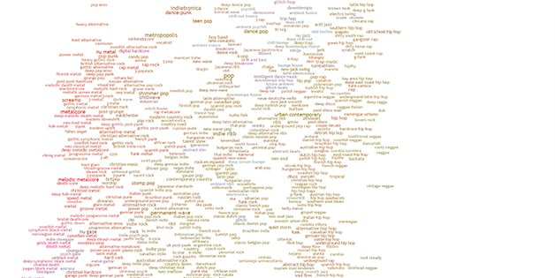

Figure 3.2.1. Every music genre from <https://everynoise.com/engenremap.html>

### 3.2.1. Audio signals

Sound is a type of energy vibrating through a medium (such as air), if there is no medium (in space) there is no sound; this energy, within a specific range of frequencies (20Hz – 20kHz), is interpreted by the human ear as sound. It is made up of three basic elements: **frequency**, how fast the vibrations are occurring, **intensity**, how loud the sound is, and **timbre**, the sound’s quality. Thus, in a physical sense, an audio signal is a representation of sound as a function of time, typically as a variation of air pressure. It can be converted to an electrical signal by a microphone and then digitized using an analog-to-digital converter.

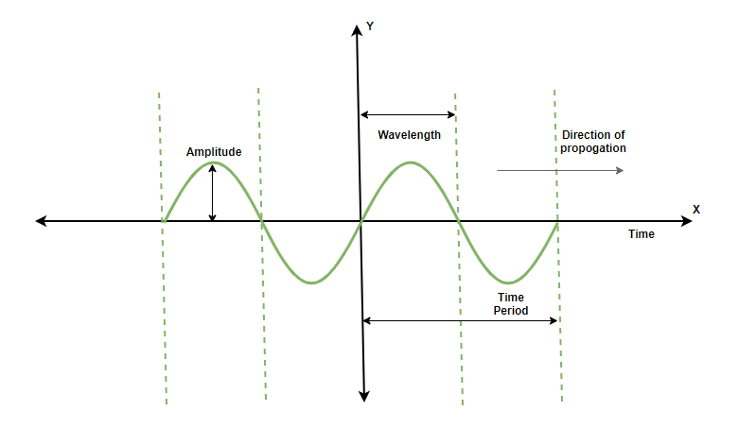

Figure 3.2.1.1. Sound waves in 2D axes

In a digital sense, the audio signal is a sequence of numbers that represents the amplitude of the signal at each point in time. For stereo audio, there are typically two such sequences (left / right channel), while mono audio consists of only a single sequence. Digital audio signals can be characterized by their sample rate (the number of samples per second) and bit depth (the number of bits used to represent each sample). For example, an audio of CD-quality has a sample rate of 44.1kHz and a bit depth of 16 bits.

There are several audio formats in which the sound can be stored and manipulated: .wav (lossless, large files), .mp3(lossy, compressed files), .flac(lossless, compressed files). In order to manipulate an audio file in Python one can use numerous libraries: Librosa, PyAudio or built-in modules.

In order to play audio files inside notebooks, IPython module offers a pretty and simple configuration:

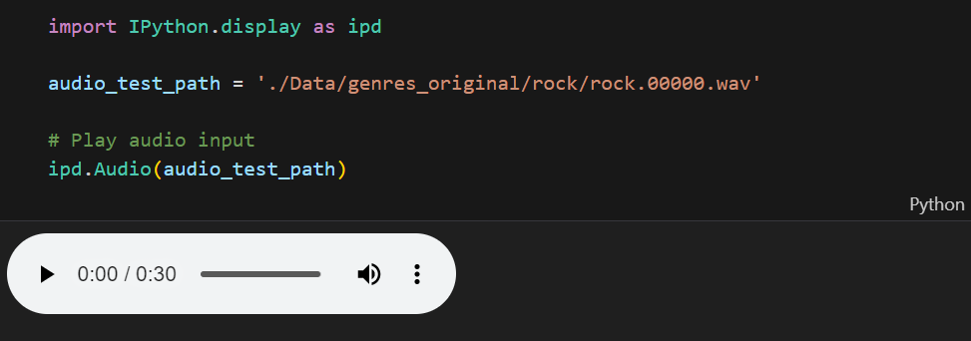

Figure 3.2.1.2. Playable in-notebook audio file

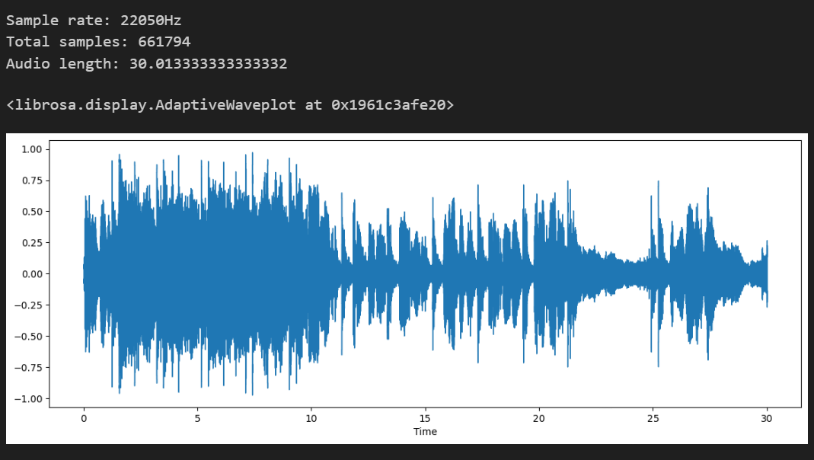

Figure 3.2.1.3. Waveform and audio specifications

In order to use audio signals / music for the task of genre classification it is necessary to extract relevant features from these signals. The features were extracted both taking into account the whole excerpt and by dividing the musical file into smaller windows. Audio features extracted can be grouped into: temporal features, chroma features, spectral features and cepstrum features.

TODO: for each category write the features

#### 3.2.1.1. Chroma STFT

[[LabCourse_STFT.pdf (audiolabs-erlangen.de)](https://www.audiolabs-erlangen.de/content/05-fau/professor/00-mueller/02-teaching/2016s_apl/LabCourse_STFT.pdf)]

The human perception of pitch is periodic in the sense that two pitches are perceived as similar in “color” (playing a similar harmonic role) if they differ by one or several octaves (an octave = the distance of 12 pitches). A pitch can be separated into two components, which are referred to as *tone height* and *chroma*. The tone height refers to the octave number and the chroma to the respective pitch spelling attribute. In Western music notation, the twelve chroma values are given by the set:

*C, C#, D, D#, E, F, F#, G, G#, A, A#, B*

A pitch class is defined as the set of all pitches that share the same chroma; for example, the pitch class corresponding to the chroma *c = 0* (*C*) consists of the set {0, 12, 24, 36, …} == {C0, C1, C2, C3, …}. The main idea of chroma features is to aggregate all spectral information that relates to a given pitch class into a single coefficient. Chroma features can be significantly changed by introducing pre/post-processing steps that modify spectral, temporal and dynamical aspects. The following chromagram is obtained by performing Short Time Fourier Transform (SFTF):

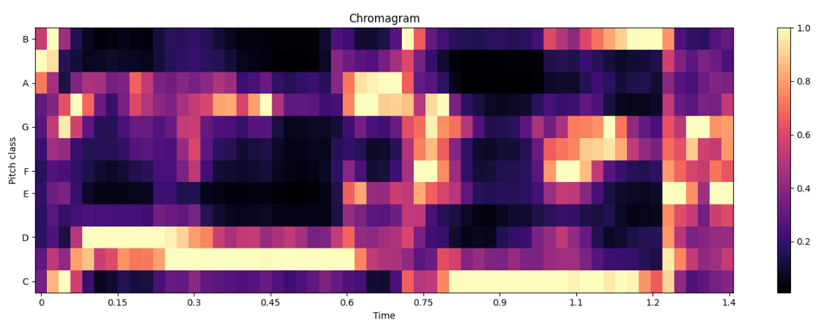

Figure 3.2.1.1.1. Chromagram on time window

#### 3.2.1.2. RMS

#### 3.2.1.3. Spectral centroid

Spectral centroid is a measure to characterize a spectrum and indicates where the ‘center of mass’ for a sound is located. In other words, it gives the frequency band where the most of the energy is concentrated. It maps into a very prominent timbral feature called “brightness of sound” (energetic, open, dull). Mathematically, it is computed as the weighted mean of the frequency bins present in the audio signal, determined using a Fourier transform, with their magnitudes as the weights:

: the weighted frequency value (magnitude) of bin number

: the center frequency of that bin

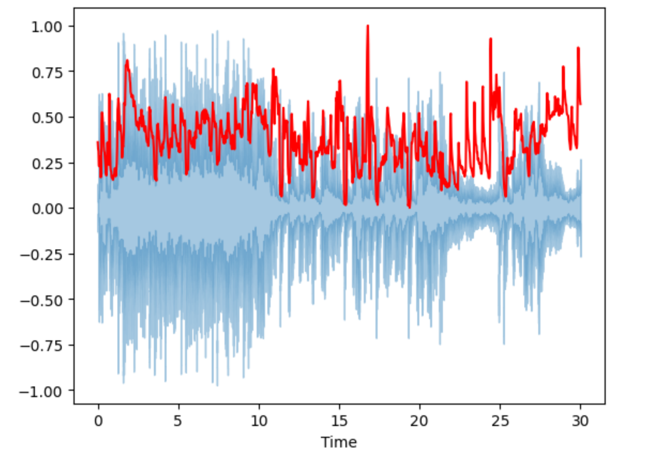

Figure 3.2.1.3.1. Spectral centroid and waveform

#### 3.2.1.4. Spectral bandwidth

The spectral bandwidth or spectral spread is derived from the spectral centroid. It is the spectral range of interest around the centroid, that is, the variance from the spectral centroid. It has a direct correlation with the perceived timbre. The bandwidth is directly proportional to the energy spread across frequency bands. It provides a measure of the spectral complexity of the sound: narrow-band signals (pure tones) have a low spectral bandwidth, whereas wide-band signals (like noise) have high spectral bandwidth. Mathematically, it is the weighted mean of the distances of frequency bands from the Spectral Centroid:

: the weighted frequency value (magnitude) of bin number

: the center frequency of that bin

: the spectral centroid

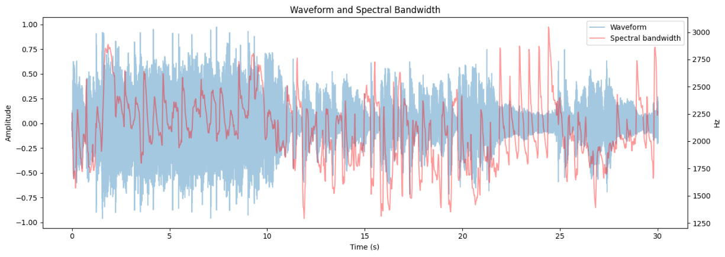

Figure 3.2.1.4.1. Spectral bandwidth and waveform

#### 3.2.1.5. Rolloff

#### 3.2.1.6. Flatness

#### 3.2.1.7. Contrast

#### 3.2.1.8. Flux

#### 3.2.1.9. Zero crossing rate (ZCR)

The ZCR is the rate of sign-changes along a signal (positive-zero-negative or negative-zero-positive). It has higher values for highly percussive sounds like those in metal and rock. The ZCR is computed as follows, where *T* is the length of the time window, is the magnitude of the time domain sample:

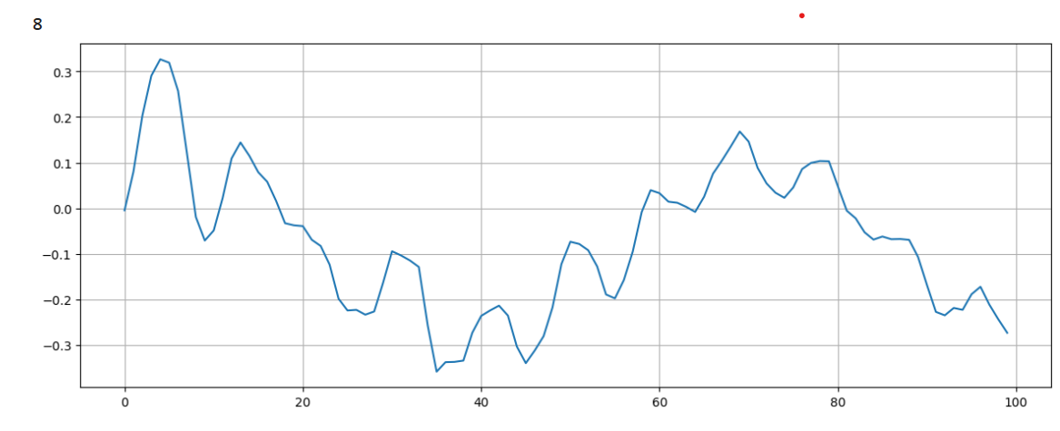

Figure 3.2.1.9.1. ZCR extracted from a time window

#### 3.2.1.10. Harmonics

#### 3.2.1.11. Percussive

#### 3.2.1.12. Tempo

In musical lingo, tempo is a that is used to describe the speed at which a song is played. In classical music, it is typically indicated at the beginning of a piece and it is usually measured in Beats Per Minute (BPM). The tempogram is a feature that represents the rhythmic structure of a musical piece in time, showing how the tempo of the track changes over time.

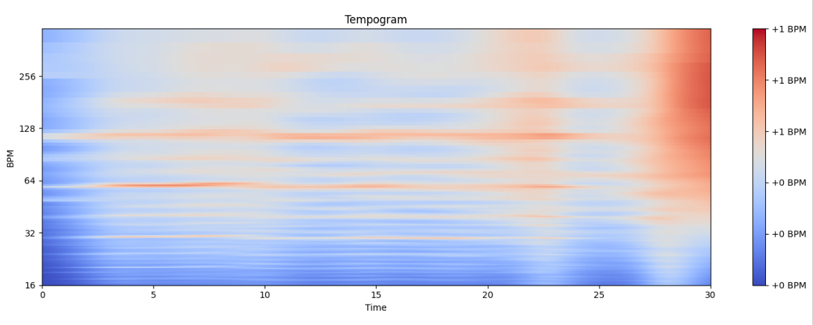

Figure 3.2.1.12.1. Tempogram of an audio file

#### 3.2.1.13. MFCC

## 3.3. Music Generation

# 4. Proposed framework

## 4.1. Music Genre Recognition

## 4.2. Music Generation

# 5. Evaluation

## 5.1. Music Genre Recognition

## 5.2. Music Generation

# 6. Conclusion and future work

# 7. Bibliography